**CHAPTER - 1**

**INTRODUCTION**

Due to the fossil fuel crisis in past decade, mankind has to focus on developing the alternate energy sources such as biomass, hydropower, geothermal energy, wind energy, solar energy, and nuclear energy. The developing of alternative-fuel technologies is investigated to deliver the replacement of fossil fuel. The focused technologies are bio-ethanol, bio-diesel lipid derived bio-fuel, waste oil recycling, pyrolysis, gasification, dimethyl ether, and biogas. On the other hand, appropriate waste management strategy is another important aspect of sustainable development since waste problem is concerned in every city.

The waste to energy technology is investigated to process the potential materials in waste which are plastic, biomass and rubber tire to be oil. Pyrolysis process becomes an option of waste-to-energy technology to deliver bio-fuel to replace fossil fuel. Waste plastic and waste tire are investigated in this research as they are the available technology. The advantage of the pyrolysis process is its ability to handle un-sort and dirty plastic. The pre-treatment of the material is easy. Tire is needed to be shredded while plastic is needed to be sorted and dried. Pyrolysis is also no toxic or environmental harmful emission unlike incineration.

Economic growth and changing consumption and production patterns are resulting into rapid increase in generation of waste plastics in the world. For more than 50 years the global production of plastic has continued to rise.

Plastic products have become integral part of our lives and play an irreplaceable role in day to day activities. It is impossible to imagine life without plastic and in other hand, production cause by plastic are become burning issues so from last few years, researchers, professors, environmentalist are very much interested in developing the technique for the management of solid waste. The consumption of plastic material is vast and has been growing steadily in the view of advantages derived from their versatility, relatively low cost, light weight, and durability. Most plastics are consumed in many applications such as packaging, building, electricity, electronics, agriculture, health cares and in different fields. Plastics are gradually replacing the materials like glass, metal, paper and so on. For the control of pollution and waste management and to promote ecological balance, the 5R’s strategies i.e. Reduce; Recycle, Reuse, Recover and Residual management has to be strictly followed through conscious human behavior and choices. According to available statistics, the total production of waste across the world in 2015 is 365 million tones and it is estimated to grow worldwide at rate of about 6.5% per year and reaches to 500 million tons by 2020. Plastics now become indispensable materials and demand is continuously increasing due to their diverse and attractive application in household and industries. There are two main types of plastics i.e. thermoplastics and thermosetting (thermo sets) polymers.

Thermosetting plastics can be re-melted into liquid by supplying enough heat and hardened on cooling so that they can be made into new plastics products. E.g.: polyethylene, polystyrene and polyvinyl chloride and many others.

Thermosetting plastics are synthetic materials that that strengthen during being heated but cannot be remolded or reheated after their initial heat forming. E.g.: phenol formaldehyde, urea formaldehyde, vulcanized rubber and fiber glasses and so on.

An optional storage to chemical recycling, which has attracted most interest recently with the aim of converting waste plastics into basic combustible products. Among the different strategies of consumption of plastic waste recycling can be the best option to meet the current environmental challenges facing the plastic industry. These are categorized into primary, secondary, tertiary and quaternary recycling. The conversion of waste plastics into combustible products depends upon the types of plastic to be targeted and properties of other wastes that might be used in the process. Additionally, the effective conversion requires appropriate technology to be selected according to the local economic environmental, social and technical characteristics. There are different methods of obtaining fuel from waste plastics such as thermal degradation (pyrolysis), catalytic cracking, and gasification.

***a. Need for Concern:***

The production of Plastic and plastic wastes are increasing rapidly and their effective and safe disposal has become a matter of a public concern. The concerned authority must be focused for the challenges, opportunities and priorities for the future to mitigate the effects caused by the plastic debris/litters on the natural environment, human health, health of animals and the adverse effect on land due to land fillings, clogging of soil and drains. So, the huge attention should pay towards disposal and wastage management of plastic products.

# **b. Current scenario of plastic waste**

Processing of the plastic wastes may become a pillar of economy for most of the advanced countries. Global economic growth is generally linked to petrochemical consumption were plastic can become an important matter. It is clearly observed that the production of synthetic polymers represented by polyethylene [PE], Polypropylene [pp], polyethylene terephthalate [PET], Polystyrene [PS], Polyvinyl chloride [PVC], Polyvinyl Alcohol [PVA] is growing violently in the world. Per capita consumption of the world is 28 kg whereas India’s 11 kg and china 38 kg, Brazil 32 kg. USA, Germany, UK, Italy, Spain, Australia, Japan, Korea, Taiwan it is more than 100 KG. An approximate 10-20 million tons of the plastic are end up in ocean each year. Each year an estimated 500 Billion, 1 million plastics bags are consumed worldwide and on average one plastic bag is recycled in every 200 bags. Plastic over 20 microns can be recycled easily so the use of thin plastics below 20 microns should be restricted.

Worldwide, the plastic and polymer consumption will have an average growth rate of 5 % and it is projected that it will touch to figure of 290 Million tons by 2020. In the same way, the average growth rate of plastics and polymer consumption in India is 10.8% and it is estimated to reach to 20 Million tons by 2020.

The following ‘Table 1.1’ provides the data on per capita consumption of plastic in the world and some other countries in the world. ‘Table 1.2’ indicates the plastic consumption in India. ‘Table 1.3’ indicates the polymers demand in India.

Table 1.1: Global per capita consumption of plastics (in keg’s)

|  |  |
| --- | --- |
| World average | 26 |
| North America | 90 |
| West Europe | 65 |
| East Europe | 10 |
| China | 12 |
| India | 5 |
| South east Asia | 10 |

## Table 1.2: plastic consumption of India

|  |  |  |
| --- | --- | --- |
| S. No. | Year | Consumption (tons) |
| 1 | 2001 | 34,00,000 |
| 3 | 2007 | 53,00,000 |
| 3 | 2010 | 85,00,000 |
| 4 | 2012 | 1,10,88,000 |
| 5 | 2014 | 1,49,60,000 |
| 6 | 2020 | 2,00,00,000 (projected) |

Table 1.3: Polymers demand in India

|  |  |  |  |  |
| --- | --- | --- | --- | --- |
| KTs | 2001 | 2007 | 2009 | 2015 |
| Polystyrene (PS) | 173 | 198 | 210 | 452 |
| Polyvinyl chloride (PVC) | 720 | 1149 | 1725 | 3472 |
| Polypropylene (PP) | 1026 | 1741 | 2207 | 4700 |
| High density polyethylene  (HDPE) | 782 | 835 | 1350 | 2600 |
| Low density polyethylene  (LDPE) | 375 | 530 | 631 | 650 |
| Linear low density  polyethylene (LLDPE) | 280 | 591 | 911 | 2164 |
| Total | 3356 | 5044 | 6747 | 14038 |

**II. Steps Involved**

The Various steps involved in the process of recycling are described as follows:

# a. Collection of Wastage plastics

Different forms of plastics are used in our day to day life such as plastic containers, jars, bottles, plastic bags, packaging plastics, plastic toys and many more household appliances.

Different collection Centers/units are established in different places according to nature and availability of plastic wastages.

Everyday tons and tons of scrap plastic are collected and sent to the collection centers for the recycling and reuse.

# b. Sorting and Cleaning

All the plastic wastages which are available cannot be of the same kind and size. They should be sorted out by their resin content and color. From here the actual recycling starts. They are mostly sorted manually by seeing the symbols at the bottom of the plastic or by the specially designed machine. The products thus obtained are washed in flood tanks or by using magnet to remove all the contaminants or the metallic impurities.

*c. Granulating or shredding*

Shredding and granulating is followed by the sorting operation. In this step, the oversized different plastics are granulated to small pieces or chunks. This step also involves cracking where the granulated plastic is break down at high temperature or at low temperature in the presence of catalyst which contain smaller carbon chain.

*d*. *Feeding to the different recycling Chamber****-***

The obtained feedstock from the above process are feed to the different recycling chamber with the suitable catalyst like Zeolite, mordenite, silica-alumina, fly ash and soon and is allowed for the further processing.

**III. Methods of conversion**

The different methods adopted for conversion of plastic solid waste into useful resources are discussed below:

# a. Gasification

Gasification is flexible, reliable process that converts low value feedstock (organic or fossil) fuel based carbonaceous material into carbon monoxide, carbon dioxide and hydrogen gas. It is a partial oxidation of plastic waste which is commonly operated at high temperature (>600⁰c - 800⁰c). The gasification agent allows feedstock to be quickly converted into gas by means of heterogeneous reaction without combustion with a controlled amount of oxygen. The air (or oxygen) factor which is used as a gasification agent is generally 20% - 40% of the amount of air needed for the combustion of plastic solid waste. The primary product is a gaseous mixture which is also known as syngas and can be used as a substitute gas.Gasification efficiently utilizes energy and recoverable raw material, inheritent in unsorted domestic waste, industrial and special waste (waste from medical) and is capable of transforming almost all total solid waste input into technically usable raw material and energy.

*b. Catalytic Cracking:*

Catalytic cracking is the process where the complex organic molecules such as mixture of organic chemical compounds or long chain hydrocarbons are broken down into simpler molecules (lighter, smaller, and simpler short chain molecules such as those of gasoline) under pressure and high temperature (350-900) in the presence of catalyst such as alumina, silica, or zeolite. This process can be applied to HDPE, LDPE, and PP. The products of this process are very useful and can be utilized as fuels having high Calorific values gas or chemicals in various applications. The prominent advantage of this method is the Catalyst used in this process lowers the reaction temperature and time. The desirable properties of the catalyst are:

1. Good stability to high temperature.
2. High Reactivity.
3. Large pore sizes.
4. Good resistance to attribution.
5. Low coke production

*c. Pyrolysis:*

It is the thermal degradation of organic material by heating to high temperature in an oxygen-starved environment. It is one of the important and best method among the different methods that are being developed and practice for producing flues from plastic waste having higher cetane value and low Sulphur contain than the fossil fuels (diesel).

The feed stocks which are made ready for the processing are feed to reactor. It is the non-combustion heat treatment process that chemically decomposes waste material by the application of the heat directly and indirectly. The endothermic reaction takes place inside the reactor chamber. The catalyst (silica, alumina, zeolite, barium carbonate, titanium chloride) are added to chamber to load the reaction temperature and time. The reaction occurs at temperature between 400⁰c-450⁰c. The Pyrolysis reaction is carried out in suitable ratio of polymer to catalyst. The vapour comes out from the reactor can be distilled to obtain different fraction of petroleum products. The different fraction depends upon type of feed, catalyst/feed ratio, temperature and time of heating. The various properties of product obtain are then tested and compared with the actual values for the petroleum range product.

**1.1 PYROLYSIS CLASSIFICATION**

Depending on the operating conditions, Pyrolysis can be classified into three main categories: conventional (slow), fast and flash Pyrolysis.

# **1.1.1 Slow Pyrolysis:**

Slow Pyrolysis is the process which takes several hours to complete Pyrolysis resulting in bio char as the main product. Slow Pyrolysis proceeds under a low heating rate (550°c-950°c) with solid, liquid and gaseous products in significant portions. It can ancient process used mainly for charcoal production. Vapours can be continuously removed as they are formed

# **1.1.2 Fast Pyrolysis:**

The process which takes fractions of minute to complete Pyrolysis called fast Pyrolysis. The temperature ranges between 850°c-1250°c. It yields 60% bio-oil in addition it gives 20% Bio char and 20% syngas. Fast Pyrolysis is currently the mostly used Pyrolysis system. The important features of fast Pyrolysis process are

* Very high heating and heat transfer rates, which require a finely ground feed
* Carefully controlled reaction temperature of around 500⁰c in the vapour phase.
* Residence time of Pyrolysis vapours in the reactor less than 1 sec.
* Quenching of the Pyrolysis vapours to give the bio-oil product.

## **1.1.3 Flash Pyrolysis:**

The present preferred technology is flash Pyrolysis at high temperature (1050°c-1300°c) with very short residence time.

**1.2 SOME INFLUENCING FACTORS TO BE CONSIDERED**

Some important factors to be considered during the plastic pyrolysis are as follows:

**1.2.1 Catalyst:**

The catalyst in the pyrolysis of plastic eventually optimizes The plastic pyrolysis reaction and modifies the distribution of pyrolysis products. The pyrolysis products are mainly straight hydrocarbons(c1-c80) which contain heavier molecular weight components, and the main result of using catalyst is to shorten the carbon chain length of the Pyrolysis product and thus to decrease the boiling point of the product. The most commonly used catalyst in the operation of the plastic waste Pyrolysis includes silica alumina, zeolite (beta, USY, ZSM-5, REY, etc.), MCM-41. It was found that REY Zeolite was the most suitable catalyst produced in the plastic with the octane number and gasoline yield.

Table 1.4: List of Catalyst

|  |  |  |  |
| --- | --- | --- | --- |
| **Sl.no** | **Catalyst** | **Commercial name** | **Pore size** |
| 1. | USY | H-Ultrstablished, Y-Zeolite | 0.74 |
| 2. | ZSM-5 | H-ZSM-5 Zeolite | 0.55*0.51 |
| 3. | MCM-41 | - | 4.2-5.2 |
| 4. | MOR | H-Mordenite | 0.65*0.70 |
| 5. | ASA | Synclyst 25 (Silica-alumina) | 3.5 |
| 6. | Silicate | Synthesized on household | 0.55*0.51 |
| 7. | SAHA | Amorphous Silica alumina | 3.28 |

**1.2.2 Temperature and pressure:**

Temperature plays the vital role in the production of fuels in the Pyrolysis method. High temperature enhances the bond breaking and thereby favoring the production of smaller molecules. Low Pyrolysis temperature does not cause the polymer to fully degrade. The extent of conversion increases with increasing in temperature and it can be seen that with higher consumption the measure product formed will be gaseous product and the liquid and solid residue will be very low. The catalyst has significantly reduced the degradation temperature as compare with pure thermal degradation in the absence of catalyst and temperature also less as compare to gasification. The operation is carried out at the atmospheric pressure and it goes on increasing inside the reactor as temperature increases.

**1.2.3 Catalyst to polymer feed ratio:**

To optimize the plastic Pyrolysis reaction, the polymer to catalyst ratio should be in a suitable proportion ratio i.e. at the ratio of 4:1(the ratio may vary according to the nature of polymer and catalyst used). Study concluded that with increasing amount of catalyst, increases the conversion up to the particular unit but further increase in the percentage of catalyst does not give any appreciable increase in the conversion rate. It also found that a lesser catalyst percentage will also provide similar degradation of the polymer but only at the higher reaction temperature.

**1.2.4 Advantages**

1. Environment friendly process design.

2. Provision for sustainable source of raw materials.

3. Reduce landfill problems.

4. Lower reaction temperature.

5. Solid, liquid &gaseous fuel can be obtained from the waste plastic.

6. Capital cost is low.

**1.4 OBJECTIVES**

The main objectives of this project are:

1. The aim of this research was to study fuel oil production from plastic wastes by sequential pyrolysis and catalytic reforming processes.

2. To establish the basis for the development and implementation of waste plastics recycling with the application of environmentally sound technologies (EST) to promote resource conservation and greenhouse gases (GHG).

3. To raise awareness in developing countries like INDIA on plastic waste and its possible reuse for conversion into diesel or fuel, this could be generated and marketed at cheaper rates compared to that of the available diesel or oil in the market.

4. To reduce the dependency on gulf countries for fossil fuels, thereby contributing to the Economic growth of the country.

**CHAPTER - 2**

**LITERATURE SURVEY**

**M. F. Ali** reported that the high yields of liquid fuels in the boiling range 100°C–480°C and gases were obtained along with a small amount of heavy oils and insoluble material such as gums and coke. The results obtained on the co-processing of polypropylene with coal and petroleum residues are very encouraging as this method appears to be quite feasible to convert plastic materials into liquefied coal products and to upgrade the petroleum residues and waste plastics.

**Sumit Bhat and Rohit Singh Lather** Utilization of waste effectively and efficiently is one the major concern in today’s world. The depleting natural resources (like fossil fuels) add further to this concern. The need of the hour is to adopt some measures which can help to manage wastes and at the same time to create some alternate fuels out of the waste only to conserve the precious fossil fuels. Thus pyrolysis these days is catching everybody’s attention due to its potential to utilize variety of waste feedstock’s to generate combustible products and may prove to be potential technology for society in the times to come. From the research work it is established that pyrolytic oil can serve as a good alternate fuel as compared to diesel because of its performance and less emissions.

**Pawar Harshal R. and Lawankar Shailendra M** Environmental concern and availability of petroleum fuels have caused interests in the search for alternate fuels for internal combustion engines. Conversion of waste to energy is one of the recent trends in minimizing not only the waste disposal but also could be used as an alternate fuel for internal combustion engines. Waste plastics are indispensable materials in the modern world and application in the industrial field is continually increasing. In this context, waste plastics are currently receiving renewed interest. As an alternative, non-biodegradable, and renewable fuel, waste plastic oil is receiving increasing attention. In the present paper waste plastic pyrolysis oil, waste plastic pyrolysis oil and its blend with diesel has been introduced as an alternative fuel. In this study, a review of research papers on various operating parameters have been prepared for better understanding of operating conditions and constrains for waste plastic pyrolysis oil and its blends fueled compression ignition engine.

[**Surjit Singh**](http://www.sciencedirect.com/science/article/pii/S0165237011001975)**,** [**Chunfei Wu**](http://www.sciencedirect.com/science/article/pii/S0165237011001975) **and** [**Paul T. Williams**](http://www.sciencedirect.com/science/article/pii/S0165237011001975)Pyrolysis of waste materials, biomass wood waste, waste tyre, refuse derived fuel (RDF) and waste plastic was performed using two thermogravimetric analyzers (TGA). One TGA was coupled to a mass spectrometer (MS) and the other to an infrared spectrometer (FTIR). The kinetic parameters of the pyrolysed waste materials obtained for TGA-MS and TGA-FTIR were compared using a model based on first-order reactions with a distribution of the activation energies. A further comparison of the volatile species evolved by thermal degradation (TGA) and the subsequent characterization by the MS and FTIR spectra was performed. The first-order reaction pathways and subsequent activation energies calculated from the differential TGA data presented good repeatability between the TGA-MS and TGA-FTIR. The TGA-MS and TGA-FTIR produced a broad spectrum of qualitative data characterizing the volatile gaseous fraction of the waste materials pyrolysed. TGA-MS and TGA-FTIR are shown to be valuable techniques in corroborating the respective thermograms and spectrograms of the volatile species evolved during the pyrolysis of waste materials. However, both techniques are prone to interference and careful interpretation of the spectra produced is required.

**M. Z. H. Khan, M. Sultana, M. R. Al-Mamun, and M. R. Hasan** The authors introduced waste plastic pyrolysis oil (WPPO) as an alternative fuel characterized in detail and compared with conventional diesel. High density polyethylene, HDPE, was pyrolyzed in a self-designed stainless steel laboratory reactor to produce useful fuel products. HDPE waste was completely pyrolyzed at 330–490°C for 2-3 hours to obtain solid residue, liquid fuel oil, and flammable gaseous hydrocarbon products. Comparison of the fuel properties to the petro diesel fuel standards ASTM D 975 and EN 590 revealed that the synthetic product was within all specifications. Notably, the fuel properties included a kinematic viscosity (40°C) of 1.98 cost, density of 0.75 gm/cc, Sulphur content of 0.25 (wt.%), and carbon residue of 0.5 (wt.%), and high calorific value represented significant enhancements over those of conventional petroleum diesel fuel.

**Anup T J, Vilas Watwe** Environmental concern and availability of petroleum fuels have caused interests in the search for alternate fuels for internal combustion engines. Conversion of waste to energy is one of the recent trends in minimizing not only the waste disposal but also could be used as an alternate fuel for internal combustion engines. Waste plastics are indispensable materials in the modern world and application in the industrial field is continually increasing. In this context, waste plastics are currently receiving renewed interest. In the present paper waste plastic pyrolysis oil, waste plastic pyrolysis oil of petrol grade and diesel grade and its blend with diesel and petrol respectively has been introduced as an alternative fuel. In this study, a review of research papers on various operating parameters have been prepared for better understanding of operating conditions and constrains for waste plastic pyrolysis oil of both grade fuel and its blends fueled in compression and spark ignition engine.

**Elizabeth A. Williams, Paul T. Williams** Plastic Waste has become an increased problem in many industrialized countries. Concern over the volumes being created has led to a number of governments introducing new legislation for its recovery as a resource. Traditional recovery methods have generally concentrated on recycling of materials or incineration for energy. The majority of polymers in waste are mainly hydrocarbon in nature and so can be used as a feedstock for the chemical industries or as a fuel. Pyrolysis is a tertiary recycling process and has an ability to provide three end products: a gas, an oil and a char which all have the potential to be further utilized. It is anticipated that if waste recovery targets currently being set are to be met then methods, such as pyrolysis, will have to be closely examined. The pyrolysis of a plastic mixture in a fluidized bed reactor was studied. The mixture was a simulated fraction of that found in municipal solid waste in Europe. The reactor was constructed of stainless steel and was 70 cm high × 10 cm diameter, with a 17 cm high × 20 cm diameter expander section. The sample was introduced batch wise into the bed. The influence of temperature on product yield and composition was studied. Pyrolysis was carried out at temperatures between 500 and 700°C. This gave widely differing product yields of between 9.79 and 88.76% gas and between 18.44 and 57.11% oil. The oils were analyzed for their functional groups using Fourier transform infrared spectroscopy. The molecular weight distribution was also determined using size exclusion chromatography. It was found that as temperature was increased the amount of aromatic compounds in the oil increased. The molecular weight range was also affected. Potential applications for the oils was also investigated.

**H. Bockhorn, J. Hentschel, A. Hornung, U. Hornung** Kinetic data obtained from micro thermogravimetry and gradient free reactor experiments confirm that different molecular structures of commodity plastics bring about different reaction mechanisms of thermal decomposition, different reaction rates, and different temperature dependencies of the decomposition rates. From that, stepwise pyrolysis of mixtures of plastics seems to be reasonable where the different components of the mixture are pyrolysed at different temperatures. To perform a stepwise pyrolysis in laboratory, scale a cascade of well stirred reactors has been developed where mixing of the reactor contents occurs by circulating of stainless steel spheres. Examples for the separation of single plastics by stepwise thermal decomposition of mixtures of poly (vinyl chloride), polystyrene and polyethylene are presented. In the "rest step hydrogen chloride from poly (vinyl chloride) is released, in the second step styrene from polystyrene is formed and in the third step aliphatic compounds from polyethylene decomposition are trapped. Differences in the thermal degradation of single polymers and mixtures of polymers, e.g. in the apparent activation energies and preexponential factors, are investigated using mixtures and blends of polyethylene and polystyrene. (1999 Elsevier Science Ltd. All rights reserved).

**Tushar M Patel, Gaurav P Rathod** Depleting quantity of Conventional Fuel has been focused as a greater problem these days. Day by day, quantity of Petroleum, Crude Oil has more utilization and lesser production. Increasing use of Petrol & Diesel has made the people of the world to think for some alternative way for energy resources. At the same time. Other rising problem against the people of the world is increase in plastic waste and recycling of the same. Both of the issues are focused and efforts are made to get optimum solution. An experimental setup has been prepared for Plastic Pyrolysis oil and Diesel Blend to be used in single cylinder, 4-stroke CI engine. Plastic Pyrolysis oil is obtained from plastic waste by pyrolysis process. Pyrolysis process is a thermo-chemical decomposition of organic matter in absence of oxygen. Blending of pyrolysis oil with diesel helps to reduce the consumption of diesel fuel. The variation in the Blending ratio of Plastic Pyrolysis Oil and Diesel fuel affects the engine performance as well as exhaust emission data. To understand the variation in Engine performance, different Blends of Plastic Pyrolysis Oil and Diesel Fuel were prepared and experimentations were done by running these blends separately in engine with various loads at Injection Pressure of 190 bar. Blends were prepared for 10%, 20%, 30% and 50% of Plastic Pyrolysis Oil with 90%, 80%, 70% and 50% of Diesel Fuel respectively. Effect of Engine performance of each were compared by Graphical representation of different performance parameters.

**Vinod Appe, Ajay Gautam, Mahendra Shrestha, Surendra Gupta** Without saving of fossils energy like crude oil, natural gas, or coal the today’s rate of economic development is unsustainable. Most of plastics that are used today are non-biodegradable in nature, they remain in environment for long period Which affects environmental quality. Plastic wastes include different type’s viz. Low Density Poly Ethylene (LDPE), High Density Polyethylene (HDPE), Poly Ethylene Terephthalate (PET), Polypropylene (PP), Polystyrene (PS), Poly Vinyl Chloride (PVC) etc. Among the alternatives to fossils energy, conversion of plastic waste to bio fuel is also one of them. The paper deals with implementation of the conversion and recycling of plastic wastes into alternative fuels. Recycling can be divided into four categories: primary, secondary, tertiary, and quaternary. As calorific value of the plastics is comparable to that of fuel, production of fuel would be a better alternative. The different methods of obtaining the fuels from plastic waste are pyrolysis /thermal degradation, catalytic cracking & Gasification. Among those, here we are discussing in brief about the pyrolysis. Uniformly graded Plastics are shredded and heated in an oxygen free chamber to about 400 degrees Celsius. As the plastic boil, gas is separated out and often reused to fuel the machine itself. The fuel is then distilled and filtered. The different fractions obtained depend upon type of feed, catalyst/feed ratio, temperature and time of heating. Catalyst and the different products are characterized for their usefulness. The various property of the products obtained were then tested and compared with the actual values for petroleum range products. Because the entire process takes place inside vacuum and the plastic is melted- not burned, minimal to no resultant toxics are released into the air as all the gases and or sludge are reused to fuel the machine. Thus, the aim of this paper is to provide best possible option available which would help in minimizing shortage of conventional fuel, address the problem of plastic waste disposal and also help in promotion of sustainable development.

**Sunbong Lee, Koji Yoshida & Kunio YoshikawaWaste** plastic can be transformed to oil by the pyrolysis and it may be applicable as a fuel for diesel engines. The pyrolysis oil property varies depending on the raw waste plastic and the pyrolysis condition, which is different from that of diesel and gasoline. Considering the thermal efficiency, the running stability and the reliability, diesel engines are the most promising energy converter to generate electricity by using the pyrolysis oil. In this research, plastics from municipal wastes were converted into oil through the pyrolysis and the catalytic reforming process in a commercial facility. Compared with diesel fuel, the raw pyrolysis oil showed slightly lower kinematic viscosity than the minimum level of diesel fuel and almost the same heating value. Its carbon class differed from diesel, gasoline and kerosene and is mainly composed of naphethenes and olefins which have poor self-ignition quality. The pyrolysis oil was blended with diesel fuel with different mixing ratios. A single cylinder small size direct injection diesel engine was used for the test.

## **2.1 SUMMARY OF LITERATURE SURVEY**

From the above literature survey it can be concluded that plastic wastes can be effectively utilized in producing wide range of products. The recycling helps to bring down the plastic wastes in landfills which is primarily responsible for environmental pollution and also make eco-friendly environment. Further it can be concluded that plastic wastes which pose hazards to human beings and the environment can be converted into useful plastic based products such as crude oil, utensils, bricks, and tiles by adopting a simple recycling method which can be carried out by small cottage industries. It is recommended that recycling should be adopted as the main method plastic waste management as it has various advantages such as reduction of the hazards that improper waste management constitute and also to reduce the tapping into fresh raw materials for development of products. In the upcoming sections of this report, the recycling of plastic wastes using plastic pyrolysis process is explained.

# **CHAPTER - 3**

# **PLASTICS**

## **3.1 OVERVIEW**

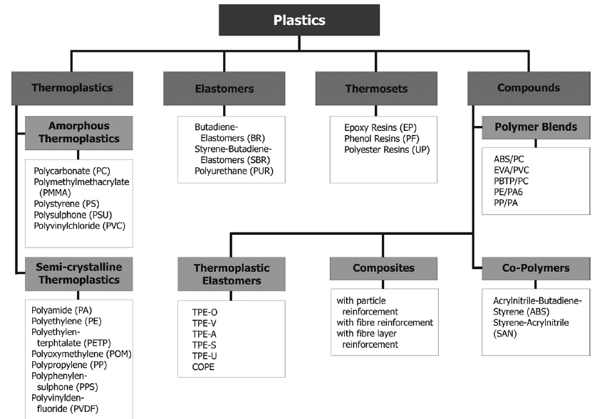

Figure 3.1: Classification of plastics

Plastics are polymers, a very large molecule made up of smaller units called monomers which are joined together in a chain by a process called polymerization. The polymers generally contain carbon and hydrogen with, sometimes, other elements such as oxygen, nitrogen, chlorine or fluorine.

There exist natural plastics such as shellac, tortoiseshell, horns and many resinous tree saps but the term “plastic” is commonly used to refer to synthetically (synthetic or semi-synthetic) created materials that we constantly use in our daily lives: in our clothing, housing, automobiles, aircraft, packaging, electronics, signs, recreation items, and medical implants to name but a few of their many applications.

These plastics are not just polymers which can be molded or extruded into desired shapes

but often contain additives that improve their performance. According to the polymer used, the synthetic and semi-synthetic plastics can be designed with a broad variation in properties that can be modified by the addition of such additives. Some additives include the following:

* Antioxidants – added to reduce the effects of oxygen on the plastics during the ageing process and at elevated temperatures.
* Stabilizers – in many cases used to reduce the rate of degradation of polyvinyl chloride (PVC).
* Plasticizers or softeners- used to make some polymers more flexible, such as PVC.
* Blowing agents –used to make cellular plastics such as foam.
* Flame retardant –added to reduce the flammability of plastics.
* Pigments –used to add colour to plastic materials.

## **3.2 THERMOPLASTICS AND THERMOSETS**

Synthetic and semi-synthetic plastics can be divided into two broad categories:

thermoplastics and thermosets.

**Thermoplastics** are plastics that can be repeatedly soften and melt when heat is applied and they solidify into new shapes or new plastics products when cooled. Thermoplastics include Polyethylene Terephthalate (PET), Low Density Poly Ethylene (LDPE), Poly Vinyl Chloride (PVC), High Density Poly Ethylene (HDPE), Polypropylene (PP) and Polystyrene (PS) among others.

**Thermosets or thermosetting** are plastics that can soften and melt but take shape only

once. They are not suitable for repeated heat treatments; therefore, if heat is reapplied they will not soften again but they stay permanently in the shape that they solidified into. Thermosets are widely used in electronics and automotive products. Thermoset plastics contain alkyd, epoxy, ester, melamine formaldehyde, phenolic formaldehyde, silicon, urea formaldehyde, polyurethane, metalized and multilayer plastics etc.

Of the total post-consumer plastics waste in India, thermoplastics constitute 80% and the

remaining 20% correspond to thermosets. Similar percentages are also representative in the rest of the world.

## **3.3 MOST COMMON PLASTIC TYPES**

Plastics are classified on the basis of the polymer from which they are made, therefore the

variety of plastics it is very extensive.

The types of plastics that are most commonly reprocessed are polyethylene terephthalate (PET), high-density polyethylene (HDPE), polyvinyl chloride (PVC), low-density polyethylene (LDPE), polypropylene (PP), polystyrene (PS) and others.

* + 1. **Polyethylene Terephthalate (PET)**

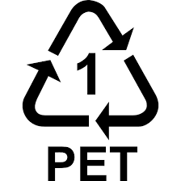

PET exists as an amorphous (transparent) and as a semi-crystalline (opaque and white) thermoplastic material. Items made from this plastic are **commonly recycled**. Generally, it has good resistance to mineral oils, solvents and acids but not to bases. The semi-crystalline PET has good strength, ductility, stiffness and hardness while the amorphous type has better ductility but less stiffness and hardness. PET has good barrier properties against oxygen and carbon dioxide. Therefore, it is utilized in bottles for mineral water. It sometimes absorbs odours and flavours from foods and drinks that are stored in them. PET plastic is used to make many common household items like beverage bottles, medicine jars, rope, clothing and carpet fibre. Other applications include food trays for oven use, roasting bags, audio/video tapes as well as mechanical components and synthetic fibers.

* + 1. **High-Density Polyethylene** **(HDPE)**

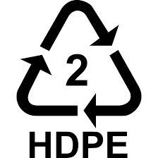

High-Density Polyethylene products are very safe and are not known to transmit any chemicals into foods or drinks. HDPE products are **commonly recycled**. HDPE is tougher and stiffer than LDPE, and is always milky white in colour, even when very thin. It is used for bags and industrial wrappings, soft drinks bottles, detergents and cosmetics containers, toys, crates, jerry cans, dustbins and other household articles. It is NEVER safe to reuse an HDPE bottle as a food or drink container if it didn’t originally contain food or drink.

* + 1. **Polyvinyl Chloride (PVC)**

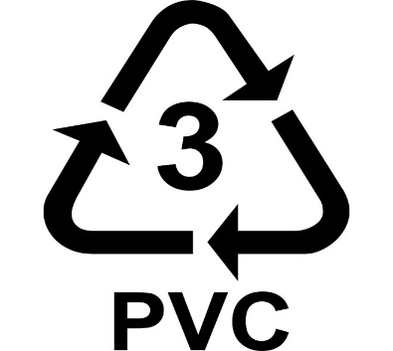

Polyvinyl chloride is a hard, rigid material, unless plasticizers are added. Polyvinyl Chloride is **sometimes recycled**. PVC is used for all kinds of pipes and tiles, but is most commonly found in plumbing pipes. This kind of plastic should not come in contact with food items as it can be harmful if ingested. Common applications for PVC include bottles, thin sheeting, transparent packaging materials, water and irrigation pipes, gutters, window frames, building panels, etc. If plasticizers are added, the product is known as plasticized polyvinyl chloride (PPVC), which is soft, flexible and rather weak, and is used to make inflatable articles such as footballs, as well as hosepipes and cable coverings, shoes, flooring, raincoats, shower curtains, furniture coverings, automobile linings, bottles, etc.

* + 1. **Low-Density Polyethylene** **(LDPE)**

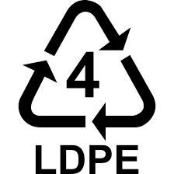

Low-Density Polyethylene is **sometimes recycled**. LDPE is soft, flexible and easy to cut, with the feel of candle wax. When it is very thin it is transparent; when thick it is milky white, unless a pigment is added. LDPE is used in the manufacture of film bags, sacks and sheeting, blow-moulded bottles, food boxes, flexible piping and hosepipes, household articles such as buckets and bowls, toys, telephone cable sheaths, etc. It is a very healthy plastic that tends to be both durable and flexible.

* + 1. **Polypropylene (PP)**

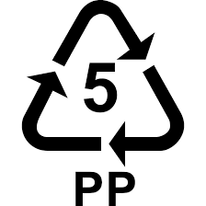

Polypropylene is more rigid than PE, and can be bent sharply without breaking. Polypropylene is **occasionally recycled.** PP is strong and can usually withstand higher temperatures. It is used for stools and chairs, high-quality home ware, strong moldings such as car battery housings and other parts, domestic appliances, suitcases, wine barrels, crates, pipes, fittings, rope, woven sacking, carpet backing, netting, surgical instruments, nursing bottles, food containers, etc.

* + 1. **Polystyrene (PS)**

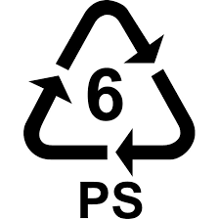

Polystyrene is commonly recycled, but is difficult to do. Items such as disposable coffee cups, plastic food boxes, plastic cutlery and packing foam are made from PS. In its unprocessed form, polystyrene is brittle and usually transparent. It is often blended (copolymerized) with other materials to obtain the desired properties. High impact polystyrene (HIPS) is made by adding rubber. Polystyrene foam is often produced by incorporating a blowing agent during the polymerization process. PS is used for cheap, transparent kitchen ware, light fittings, bottles, toys, food containers, etc.

* + 1. **Other**

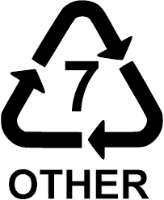

Code 7 is used to designate miscellaneous types of plastic not defined by the other six codes. These types of plastics are **difficult to recycle**. Other plastics extensively used in our daily lives are as follow:

* **High Impact Polystyrene (HIPS) –** used in fridge liners, food packaging, vending cups**.**
* **Acrylonitrile butadiene styrene (ABS) –** used in electronic equipment cases (e.g., computer monitors, printers, keyboards), drainage pipe.
* **Polyester (PES) –** used in fibers, textiles.
* **Polyamides (PA) (Nylons) -** used in fibers, toothbrush bristles, fishing line, under-the hood car engine mouldings.
* **Polyurethanes (PU) -** used in cushioning foams, thermal insulation foams, surface coatings, printing rollers.
* **Polycarbonates (PC) -** used in CDs, eyeglasses, riot shields, security windows, traffic lights, lenses.
* **Polycarbonate/Acrylonitrile Butadiene Styrene (PC/ABS)** - A blend of PC and ABS that creates a stronger plastic. Used in car interior and exterior parts and mobile phonebodies. 

Figure 3.2: Melt-temperature ranges and decomposition in the molten state of some thermoplastics



Figure 3.3: Properties and applications of plastics

## **3.4 FILM/SOFT – RIGID/HARD PLASTICS**

One common classification with regards to waste plastics is rigid/hard and film/soft plastics. Plastic films are technically defined as plastic sold in thicknesses of up to 0.0254 mm, or 25.4 μm. However, it is usually referred to plastics which are typically thin items, pliable sheets or collapsible tubes (e.g. shopping bags, trash bags and packaging materials for many different products).

On the other hand, rigid plastics have the properties to be sturdy and self-supporting (e.g.

cosmetic and toiletry bottles, soft drink and water bottles, basins, pails, trays, various containers and many others).

The most common polymer used in film plastics is low density polyethylene (LDPE) and

shrink wrap, which is a linear low density polyethylene (LLDPE) designed to stretch. HDPE is also extensively used. PP film is commonly used to package cigarettes, candy, snack food and sanitary goods. PVC film is used in some bags and liners, labels, adhesive tape and to package fresh red meats. PET films is found in non-food, non-packaging applications such as magnetic audio, photographic film and video recording film.

Similarly, rigid plastics are composed of a broad variety of polymers (e.g. In agriculture the most used resin types are mainly HDPE, PP and PS. Common products are nursery pots, trays, flats, tray inserts, baskets and hangers, pails and barrels).

This classification (film-rigid plastics) is based on common properties/features of the plastics but does not refer to the composition of the material.

## **3.5 PLASTIC/RESIN IDENTIFICATION CODE**

The Society of the Plastics Industries (SPI) developed in 1988 the resin identification code to facilitate the recycling of post-consumer plastics by providing manufacturers a consistent and uniform system to identify the resin content of plastic bottles and containers. The SPI coding, by which a number is recorded within the plastic item to specify the type of polymer used in its manufacture process, focused on the plastic packaging commonly found in the residential waste stream. The majority of plastic packaging is made of six type of polymers such as polyethylene terephthalate (PET or PETE); high density polyethylene (HDPE); polyvinyl chloride (PVC or vinyl); low density polyethylene (LDPE); polypropylene (PP); or polystyrene (PS). Therefore, SPI resin identification code assigned each of these resins a number from 1 to 6. Additionally, this system included a seventh code, identified as "other" indicating that the product in question is made with a resin other than the six listed above, or is made of more than one resin used in combination.

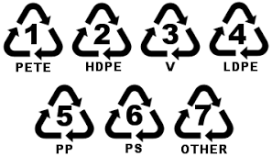

Figure3.4: Plastic Identification Code

Unfortunately, the Plastic/Resin Identification Code is not worldwide used and this classification is not followed in most of developing countries where usually the waste plastics are either covered under one category, “plastics” or two categories, “rigid and soft/film plastics”.

## **3.6 PLASTICS WASTE: ENVIRONMENTAL ISSUES AND CHALLENGES**

The quantum of solid waste is ever increasing due to increase in population, developmental activities, changes in life style, and socio-economic conditions, Plastics waste is a significant portion of the total municipal solid waste (MSW). It is estimated that approximately 10 thousand tons per day (TPD) of plastics waste is generated i.e. 9% of 1.20 lacs TPD of MSW in the country. The plastics waste constitutes two major category of plastics; (i) Thermoplastics and (ii) Thermoset plastics. Thermoplastics, constitutes 80% and thermoset constitutes approximately 20% of total post-consumer plastics waste generated in India. The Thermoplastics are recyclable plastics which include; Polyethylene Terephthalate (PET), Low Density Poly Ethylene (LDPE), Polyvinyl Chloride(PVC), High Density Poly Ethylene (HDPE), Polypropylene(PP), Polystyrene (PS) etc. However, thermoset plastics contains alkyd, epoxy, ester, melamine formaldehyde, phenolic formaldehyde, silicon, urea formaldehyde, polyurethane, metalized and multilayer plastics etc. The environmental hazards due to mismanagement of plastics waste includes the following aspects:

* Littered plastics spoils beauty of the city and choke drains and make important public places filthy;
* Garbage containing plastics, when burnt may cause air pollution by emitting polluting gases;
* Garbage mixed with plastics interferes in waste processing facilities and may also cause problems in landfill operations;
* Recycling industries operating in non-conforming areas are posing unhygienic problems to the environment.

## **3.7 IMPORTANCE OF PLASTIC RECYCLING**

It has been observed, to reduce bad effects of waste plastics, it is better to recycle and re-utilize waste plastics in environment-friendly manners. As per statistics, about 80% of post-consumer plastic waste is sent to landfill, 8% is incinerated and only 7% is recycled. In addition to reducing the amount of plastics waste requiring disposal, recycling and reuse of plastic can have several other advantages, such as:

* Conservation of non-renewable fossil fuels – Plastic production uses 8% of the world’s oil production, 4% as feedstock and 4% during manufacture.
* Provision of a Sustainable Source of raw Materials.
* Reduced consumption of energy.
* Reduced amounts of solid waste going to landfill.
* Reduced emissions of carbon-dioxide (CO2), nitrogen-oxides (NOx) and sulphur-dioxide (SO2).

## **3.8 RECYCLING TECHNIQUES**

There are four main approaches for recycling of Plastic solid waste (PSW); as primary, secondary, tertiary and quaternary recycling.

Recycling technique of polymer does play an important role in the generation of new polymer. Every technique has its own advantages and disadvantages. When material undergoes a recycling process it starts losing some of properties in terms of tensile strength, wear properties and dimensional accuracy. Further some of the recycling techniques are elaborated below.

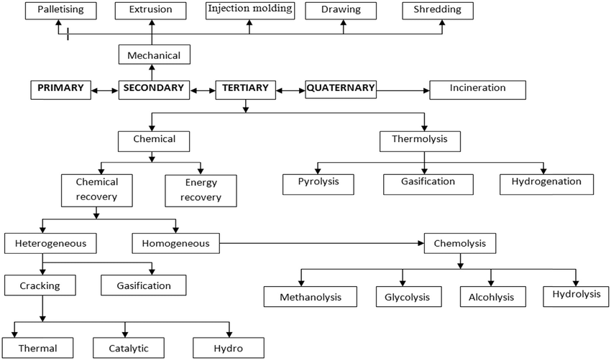

Figure 3.5: Various approaches for recycling of PSW

**3.8.1 Primary recycling**

Primary recycling better known as re-extrusion or closed loop process is recycling of uncontaminated, single type of polymer having properties near to virgin material. This process utilizes scrap plastics that have similar features to the original products. It can only be done with clean or semi-clean scrap after successfully sorting out the contaminated parts. Usually Municipal Solid Waste (MSW) is not suitable for primary recycling due to excess contamination. Some time to obtain better properties in comparison with virgin material, introduction of clean scrap is made into collected waste. This technique is easy to use and popular in manufacturers, because of conversion of plastic waste into original quality product. More or less it includes injection moulding and other mechanical recycling techniques; difference is about the quality of material.

**3.8.2 Secondary recycling**

Primary and secondary recycling techniques are well established and widely applied techniques. Although both of these are linked to mechanical recycling of plastic and used for recycling of PSW by mechanical means. Secondary recycling is transformation of material by mechanical mean for less demanding products. The steps involved in secondary recycling are usually: Cutting/shredding, Contaminant separation, flakes separation by Floating. After these steps single polymer plastic material is processed and milled together to form granulated form. Then pre washing followed by drying is done to remove all kinds of glue particles. Sometime chemical washing by using caustic soda is done for glue removal. Then the product is collected, stored and sold after addition of pigments and additives.

Further extrusion of plastic strands is done by making pallets according to requirement and then final products are made. described two approaches for recycling of polymer waste. The first one being separation of plastic from their contaminants and segregating it into generic form further recycling it into products produced from virgin material. Another approach is after separation from contaminants and re-melting it without segregation. Secondary recycling includes various methods of recycling (like screw extrusion, injection moulding, blow moulding etc.). One such method namely screw extrusion is discussed as under: -

**3.8.2.1 Screw extrusion**

Extrusion methods are widely used for the processing of polymers and composites containing them, agricultural raw materials, food, waste, meat, and leather, as well as other raw materials. Now a day's single and twin screw extruder are available for the recycling of processing of the materials. But both have their different process parameters. Single-screw and twin-screw has some differences and benefits depending on the plastic being processed. Various varieties of extruders according to sizes, shapes and methods of operations are available. In polymer processing technology screw extrusion is the most important operation. Plastic extrusion is a process in which the material having some polymer chain can be altered by heating up to its melting point. In this, the material is put into barrel and then heated up to a specific level and forced to move through some die that is having required dimensions, after which material comes out of the die as per die shape. Most commonly, plastically extruded materials are in cylindrical shape. To maintain the uniformity of extruded material, some arrangements are made to preheat the material. Time of cooling and speed of rolling of the material play a major role in dimensional accuracy and properties of the wire being extruded. Most of the plastic materials are available in powder shape or granules. They are processed at room temp. The plastic extrusion machine melts the material and homogenizes it before entering into the die. Conversion from cold to hot state accounts some energy. The shape of the material depends on many factors which include pressure, flow rate of material (MFI), orifice shape, and cross section of extruded and most important the rheological properties of the material. MFI determination is the standard test for getting rheological property of polymer. The ratio of the channel depth in the feed section to the channel depth in the metering section is often referred to as the compression ratio of the screw. For having effective pumping action, the volume of feed should be 2 or 3 times the volume at the front and this ratio of volume is called the compression ratio.

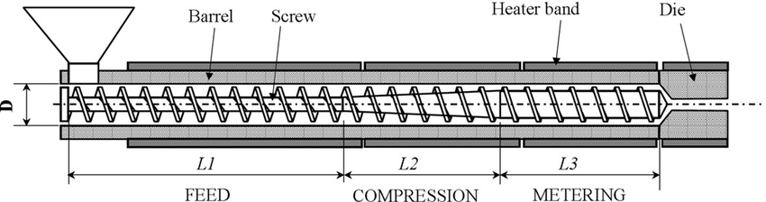

Figure 3.6: Schematic diagram of single screw extruder

Mainly, this machine has following listed parts:

* Hopper
* Cylindrical barrel
* Screw
* Die head
* Motor for running of the screw

Different types of materials are available in the market in powder form and granule form. The material into barrel through hopper under the gravity action. The cylindrical barrel is surrounded by the heaters that can be controlled manually with a set of specific temp range. Generally, the temp range of normal screw extruder is up to 275 ℃, which is enough to melt thermoplastic materials. As material enters into the barrel, the material starts heating up. The screw starts leading the material in the forward direction towards the die. The length of barrel plays a major role. The role of screw speed is also important. If the screw is having more speed, then the material will not melt properly, as the material will lead at faster speed. And if the speed of screw is low, then material will be over melted and the wire will not form properly. Melting temperature being an important parameter plays a major role in the flow properties of polymers. The screw pushes the material positively into the barrel and lead it to the die. There can be multiple heating zones. Those heating zones gradually increase the temp of the material. The pressure, which screw is exerting on the material may reach to 5000 psi (34 MPa). Then material reaches to the breaker plate that create back pressure. This is required for uniform mixing and uniform melting of material. After passing through the breaker plate, material comes to the die and starts passing through it and thus wire is formed.

**3.8.3 Tertiary recycling**

Primary and secondary recycling techniques are sometimes difficult to process, since it includes identification and sorting of material by various methods. In primary recycling un-contamination of polymer waste is a difficult task because most of the MSW is a collection of heterogeneous components. Specially in secondary recycling the in homogeneity of municipal solid waste makes it very difficult to be recycled.

It is a known fact that polymer is made up of petroleum based products. Primary and secondary both techniques do not contribute towards the principle of energy sustainability. On the other hand, of tertiary recycling proves its contribution towards the principle of energy sustainability. Because it leads to the generation of the raw materials from which the plastics are originally made, therefore attaining attention of recyclers. It involves various Methods of recycling including pyrolysis, cracking, gasification and chemo lysis. Basically recovery of monomers from PSW from depolymerisation process is called tertiary recycling. Chemical and thermal recycling are the major types of tertiary recycling techniques available. Depolymerisation of PSW by chemical means and heat is called solvolysis and thermolysis respectively. Further process is called pyrolysis if done in the absence of air. If done in controlled environments, then it is called gasification. The degradation of polymers in the presence of glycol like diethylene or glycol ethylene glycol is known as glycolysis and the degradation of polymers in the presence of methanol is known as methanolysis and this is also an example of transesterification.

**3.8.4 Quaternary recycling**

After a number of recycling cycles of PSW by primary, secondary and tertiary techniques material start losing its properties. The only way to discard the waste is to land fill. But land filling of material leads to contamination of earth's surface. The more effective ways of disposal of waste goes through quaternary recycling of material or waste. MSW disposal by combustion is increasing due to increase in efficiency of new incinerators. In quaternary recycling waste material is processed to recover energy through incineration. It also leads to volume reduction of waste and rest can be land filled.

Table 3.1: Calorific values of various available polymers

|  |  |
| --- | --- |
| **Item** | **Calorific value (MJ kg-1)** |
| Polyethylene | 43.3 - 46.5 |
| Polypropylene | 46.50 |
| Polystyrene | 41.90 |
| Kerosene | 46.50 |
| Gas oil | 45.20 |
| Heavy oil | 42.20 |
| Petroleum | 42.3 |
| Household PSW mixture | 31.8 |

Recycling of plastic waste by the energy recovery method is logical only when recycling of waste is not possible due to constraints. As it is well known that plastic materials are derived from crude oil and they posses' very high calorific value. Above table demonstrates the calorific value for different plastic polymers as compare to oil and petroleum. A number of environmental concerns are associated with co-incinerating PSW, mainly emission of certain air pollutants such as CO2, NOx and SOx. The combustion of the PSW is also known to generate volatile organic compounds (VOCs), smoke (particulate matter), particulate-bound heavy metals, polycyclic aromatic hydrocarbons (PAHs), polychlorinated dibenzofurans (PCDFs) and dioxins. While combustion, emission of harmful and environmental polluting gases is major issue involved. That can be controlled by different methods, (i) activated carbon addition, (ii) flue gas cooling, (iii) acid neutralization, (iv) ammonia addition to the combustion chamber and/or (v) filtration.

## **3.9 APPLICATION OF RECYCLED POLYMERS**

Recycled Polymer/plastic is highly used in manufacturing industries for the preparation of products. Industries are more interested in cost reduction, hence using recycled material is better choice for cost reduction and also helpful in reducing waste. Polymers are an excellent and a very useful material to replace ceramic, wood and metals because they are very functional, hygienic, light and economical. One of the very interesting applications of recycled plastic is manufacturing of plastic lumber (timbre) using post-consumer based plastic (polyolefin) for construction of docks, marine piling, pier and dock surfaces, fences, park benches, Piers and bulkheads and examines the long-term engineering properties of plastic lumber manufactured using post-consumer waste plastic. Most of the feedstock used for plastic lumber is composed of polyolefin {high density polyethylene (HDPE), low density polyethylene (LDPE) and polypropylene (PP)}. Reinforcement of various plastic waste material results in improvement in in-plane compression modulus, dimensional stability and surface hardness. Another example of recycled plastic waste is wood, plastic composite. Wood is the basic material for furniture, interior decorating, and construction industries.

Wood plastic composite (WPC) has got good properties in terms of low moisture absorption, low density, resistance to biological attack, good dimensional stability, and a combination of high specific stiffness and strength. WPC tends to be a good intermediate step in the cascade chain of biomass and are recyclable. Use of recycled plastic in development of renewable energy technologies by recovering and storing the heat is also a new area of research which is being explored. For this recycled HDPE reinforced with graphite is used and a composite has been made by improving thermal properties by optimization of manufacturing processes and varying the composition of a mixture of both HDPE and graphite. Biodegradability is a limitation of plastic material, but this nature of a plastic can be used in another way preparing those parts which are more prone to environmental conditions and need more life span. By recycling various types of plastic material by combining HDPE, PET, LDPE, PP in various compositions, cylindrical parts were made from that composition and finally spur gears were made for end user application. Different researchers have worked on improvement of various properties of asphalt by incorporating various recycled polymers. Asphalt pavement is any paved road surfaced with combination of approximately 95% stone, sand, or gravel bound together by asphalt cement, a product of crude oil. Incorporation of polymer material (PET) in stone mastic asphalt showed significant improvement in mechanical and volumetric properties. These are some of the other uses:

* **Packaging**

Recycled PET and HDPE is increasingly used in primary packaging by retailers and branded manufacturers for bottles and trays. Use of recycled plastic helps demonstrate a commitment to sustainable resource use.

* **Construction**

Recycled plastic is widely used in mainstream construction products such as damp proof membrane, drainage pipes, ducting and flooring. It is also used in innovative products such as scaffolding boards or kerbstones, where its durability and weight has significant Health & Safety benefits.

* **Landscaping**

Walkways, jetties, pontoons, bridges, fences and signs are increasingly being made from recycled plastic.

Durability, low maintenance, vandal resistance, and its resistance to rot are all key reasons for plastic being used.

* **Textile fibre / clothing**

Polyester fleece clothing and polyester filling for duvets, coats etc is frequently made from recycled PET bottles (e. g. soft drink and water bottles). Polyester fibre is the largest single market for recycled PET bottles worldwide.

* **Street furniture**

Street furniture, seating, bins, street signs and planters are frequently made from plastic. They are cost competitive and resistant to vandalism. Local authorities and schools are able to demonstrate recycling in action by specifying recycled products.

* **Bin liners/ refuse sacks**

Plastic film from sources such as pallet wrap, carrier bags, and agricultural film are made into new film products such as bin liners, carrier bags and refuse sacks on a large scale.

**CHAPTER - 4**

**CHARACTERISTICS OF PLASTICS AND OIL PRODUCTS**

Before looking at the process options for the conversion of plastic into oil products, it is worth considering the characteristics of these two materials, to identify where similarities exist, and the basic methods of conversion. The principal similarities are that they are made mostly of carbon and hydrogen, and that they are made of molecules that are formed in “chains” of carbon atoms.

Crude oil is a complex mixture of hydrocarbons, which are separated and purified by distillation and other processes at an oil refinery. The majority of the crude oil is used for the production of fuels for transportation, heating and power generation. These oil products are not single components, but are a blend of components used to meet the relevant fuel specifications in the most economic manner, given the composition of the crude oil and the configuration of the oil refinery. These components have a wide range of chain lengths: gasoline has compounds with a chain length of between three and 10 carbon atoms, and diesel has compounds with a chain length of between five and 18 carbon atoms, but both contain only hydrogen and carbon.

Plastic is a generic term for a wide range of polymers produced using highly refined fractions of crude oil, or chemicals derived from crude oil, known as monomers. Polymers are formed by the reaction of these monomers, which results in chain lengths of tens or hundreds of thousands of carbon atoms. Some polymers also contain oxygen (e.g. polyethylene terephthalate (PET)), whereas others contain chlorine (polyvinyl chloride (PVC)). It is worth noting that only a small proportion (< 5%) of the crude oil processed in the world is used to produce the monomers (e.g. ethane, propene) used in the manufacture of polymers (e.g. polyethene, polypropylene).

The similarity between oil products and plastics is illustrated in Figure 2. The figure demonstrates where the atomic composition in most plastics is similar to those in gasoline and diesel derived from crude oil.

Figure 4.1: Atomic composition of fuel and plastic

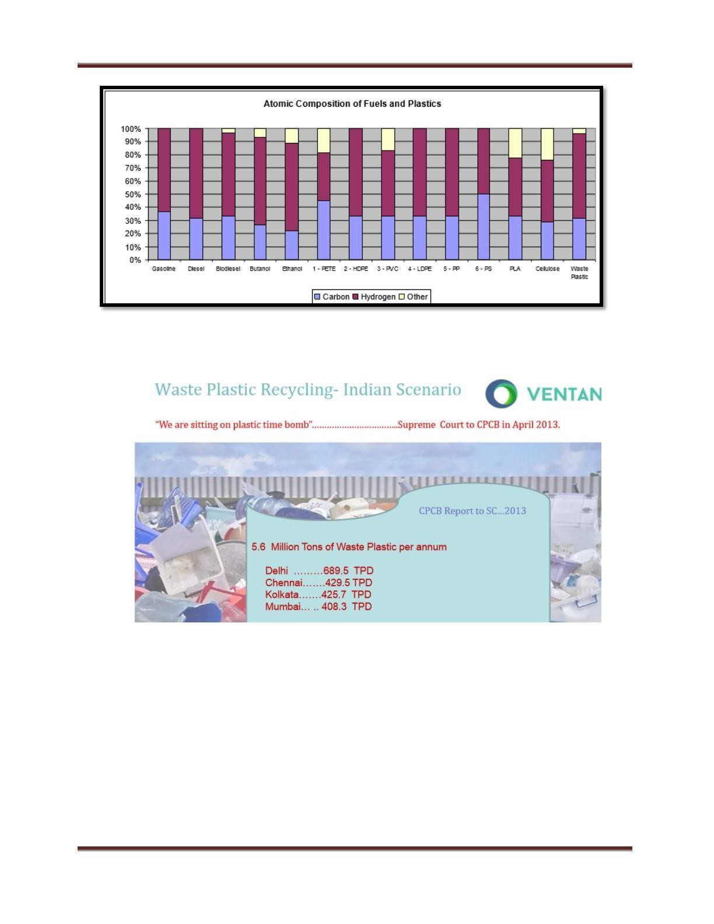

Figure 4.2: Waste plastic recycling



**CHAPTER - 5**

**METHODOLOGY**

1.Identification of waste plastics. (PE/PP/PS/LDPE/HDPE)

2.Subjecting the waste plastic for pyrolysis process.

3.Condensation of the gas to obtain raw fuel.

4.Conversion of raw fuel into its pure form (diesel etc.) by the process of distillation.

**5.1 COLLECTION & IDENTIFICATION OF WASTE PLASTIC:**

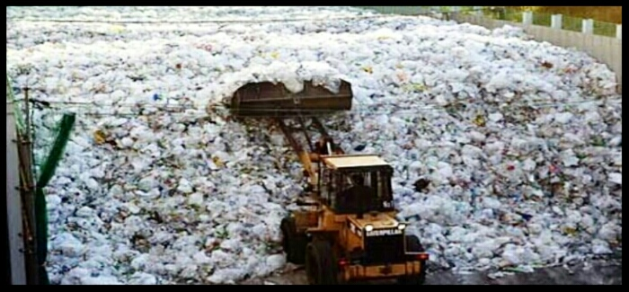

Figure 5.1: Waste plastic dumping yard

* The collection of waste plastic is quite an easy task as compared to other wastes, the plastic wastes are abundant and can be obtained in large quantities from the households, roadsides, hospitals, hotels etc.

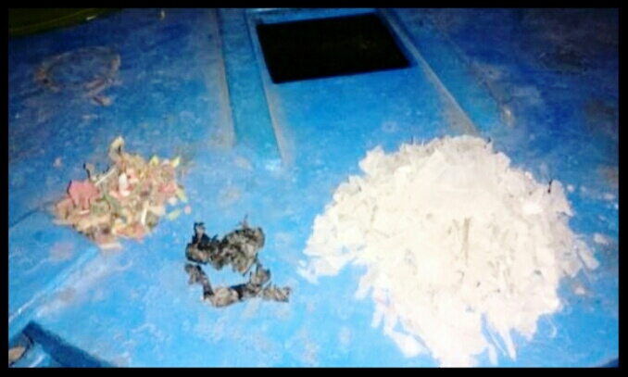

Figure 5.2: Different type of plastic

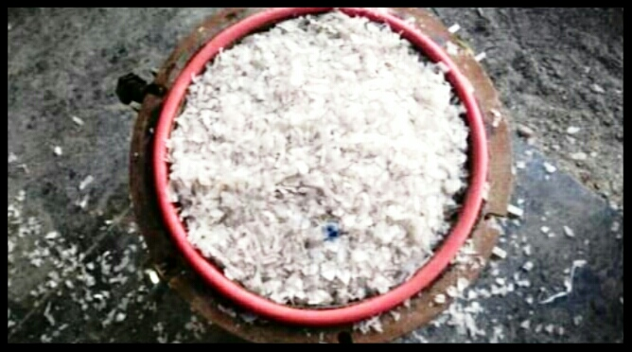

Figure 5.3: chopped plastic

* This plastic is usually termed as
* POLYETHYLENE (PE)
* POLYPROPYLENE (PP)
* HIGH DENSITY POLYETHYLENE (HDPE)
* LOW DENSITY POLYETHYLENE (LDPE)

Usually they are manufactured in the form of plastic bags, saline bottles, plastic tools, chairs and other components which we usually come across in our day to day life. These plastics could be collected or usually purchased at Rs.10 to 15/kg after being shredded and washed properly.

**5.2 SUBJECTING THE WASTE PLASTIC FOR PYROLYSIS**

Figure 5.4: Conceptual design of reactor for pyrolysis process

**PROCESS:**

The pyrolysis is a simple process in which the organic matter is subjected to higher temperature about 150ºC to 200ºC in order to promote thermal cracking of the organic matter so as to obtain the end products in the form of – liquid, char and gas in absence of oxygen.

**5.2.1. WHY WE ADOPT PYROLYSIS PROCESS:**

* Reduction in volume of waste (<50–90%),
* All the three types of fuel like solid, liquid and gas can be produced,
* The fuel obtained can be stored and transported easily,
* The problems related with environment are greatly reduced,
* Energy can be derived from renewable sources like municipal solid waste or sewage sludge,
* It involves low capital cost

**5.2.2 EXTRATION PROCES IN SPECIALY DESIGNED MOULD (PYROLYZER):**

The below picture shows the mould prepared by us so as to serve as a **pyrolyzer device**.

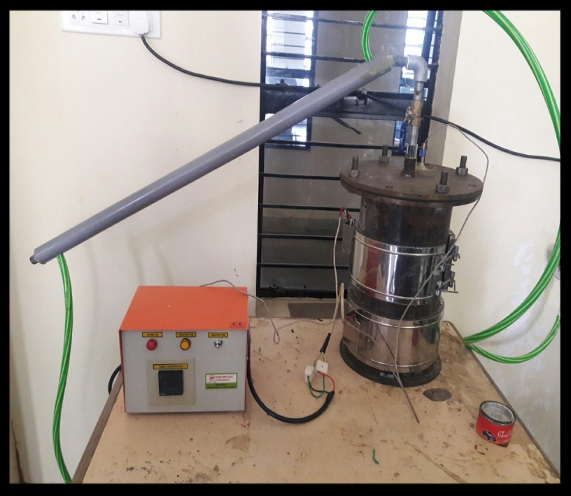

Figure 5.6: redesigned reactor for pyrolysis process

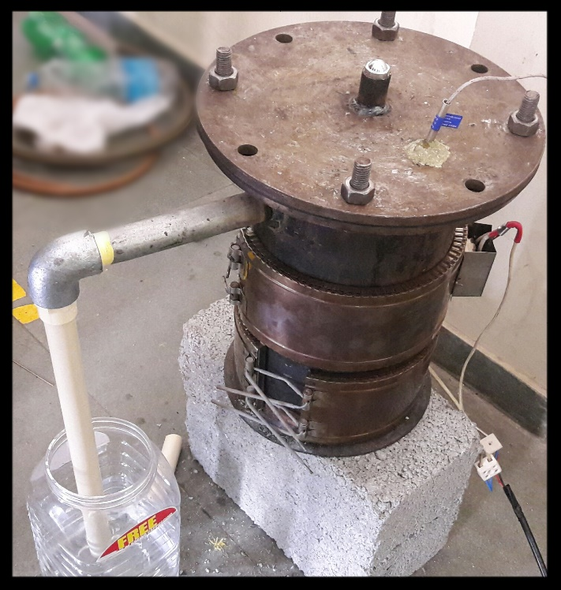

**5.3 DESIGN DETAILS OF THE INSTRUMENT:**

* Material = Mailed Steel
* Top diameter = 25 cm
* Bottom diameter = 25 cm
* Depth = 40 cm
* Volume = 19634 cm
* Diameter of outlet = 2.54 cm
* Weight of mould = 14 kg
* Digital thermometer (up to 2000°C)
* Electric Band heater

Figure 5.7: Fabricated reactor

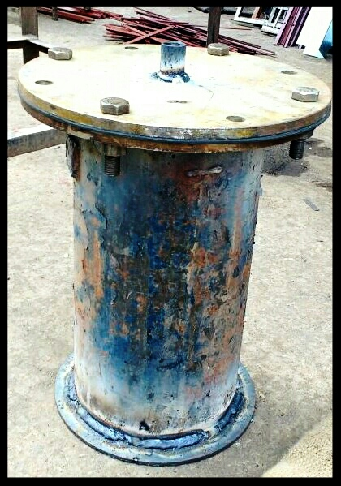

## 

## **5.4 TECHNICAL FEATURES**

**5.4.1 Ceramic band heater**

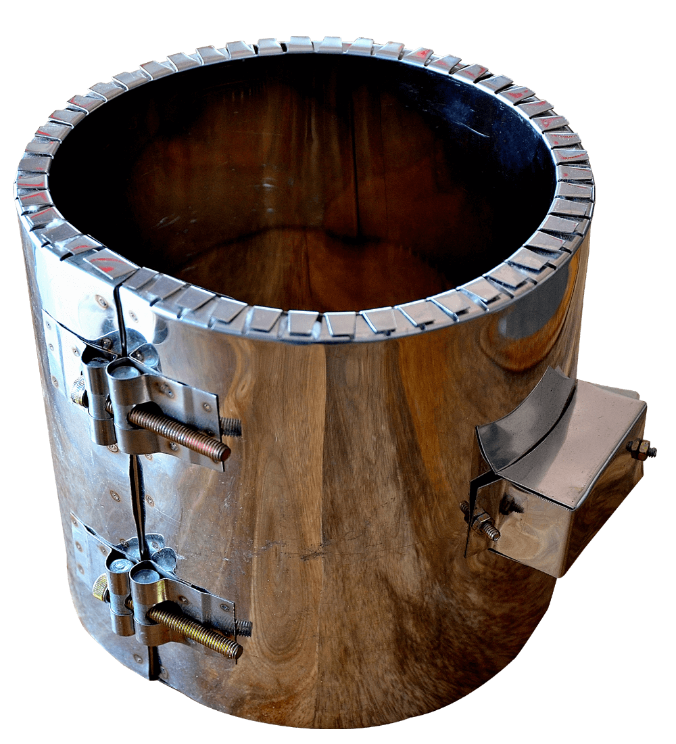

Figure 5.8: Ceramic band heater

Diameter – 160 mm

Height – 180 mm

Power / Wattage – 2 Kw

Voltage – 230 V

Maximum temperature - 420℃

Sheath material – Stainless steel

Insulation material – Ceramic fibre blanket

**Use**

* Plasticization cylinders for molding machines or extruders.
* These band heaters are the ideal solution for heating cylindrical surfaces in many other applications.

**Advantages**

* Excellent heat exchange to the cylinder.
* Heating uniformity.
* Long life of the heater (when properly used).
* Easy to install.
* High mechanical resistance.
* Constant quality with time.
* It is very important underlining that for this heater, heat exchange takes place both for conduction and radiation.
* Energy saving is an important characteristic because the ceramic fibre layer, placed between the ceramic and the external casing, reduces of about 20% energy consumption, if compared to a normal band heater.

**5.4.2 Digital temperature controller**

Type – PID controller (proportional–integral–derivative controller)

Size – 8X8X6 control panel

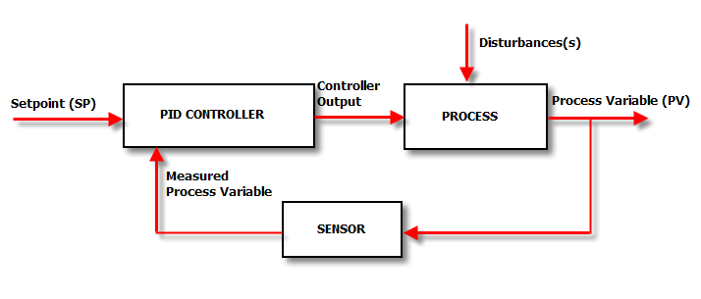

Figure 5.9: Block diagram of a process under control system

A proportional–integral–derivative controller (PID controller) is a control loop feedback mechanism. As the name suggests, PID algorithm consists of three basic coefficients: proportional, integral and derivative which are varied to get optimal response.

**5.4.3 Thermocouple**

Type – K

Temperature Range – 0-800°C

Probe diameter – 5 mm



Figure 5.10: K type thermocouple

The Type K thermocouple has a Chromel positive leg and an Alumel (Nickel- 5% Aluminium and Silicon) negative leg. Type K is recommended for use in oxidizing and completely inert environments.

**5.5 CONDENSATION OF GAS TO OBTAIN CRUDE OIL:**

After heating the waste plastic at a temperature of about 3000C to 5000C in the pyrolyzer the gas is allowed to escape through the outlet dipped into the water containing jar so as to condense the fumes to obtain the RAW FUEL floating over the surface as shown in picture above, which is further taken out through the outlet provide to the water containing jar.

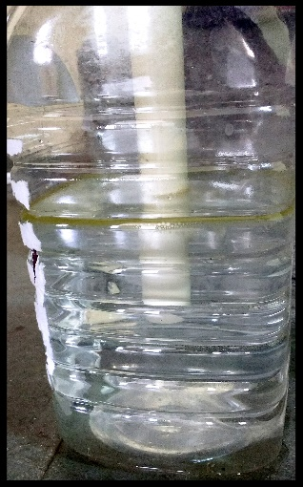

Figure 5.11: Initial condition before Condensation

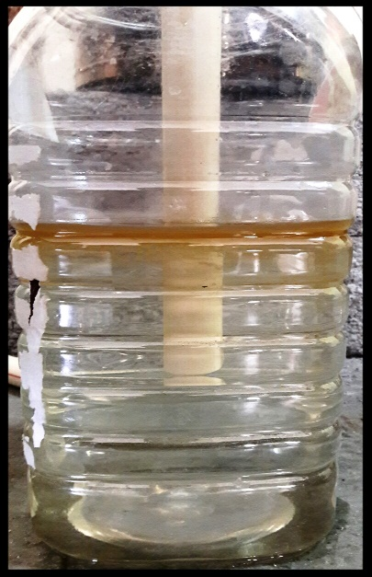 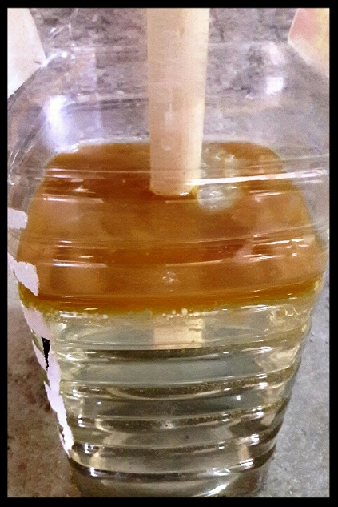

Figure 5.12: A layer of oil formed at the top surface after Condensation of the gases.

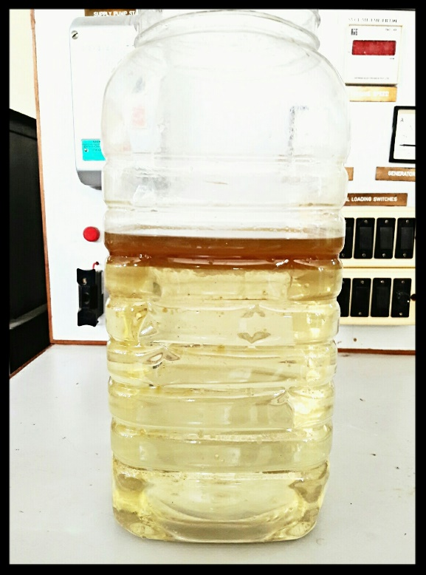

Figure 5.13: Crude oil collected from about 750gm of Plastic

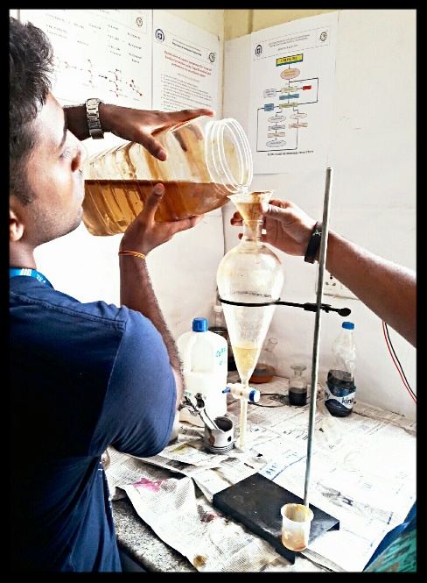 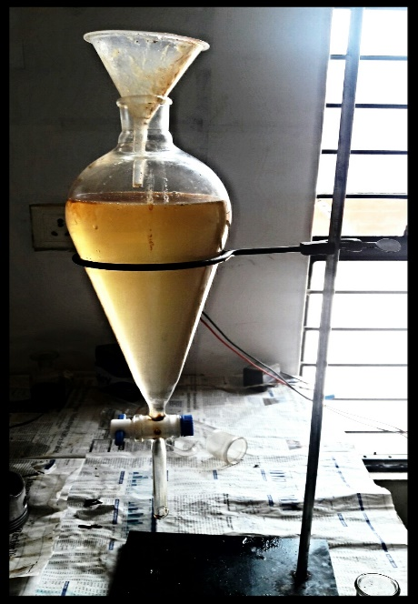

Figure 5.14: Subjecting crude oil and water mixture to sedimentation process

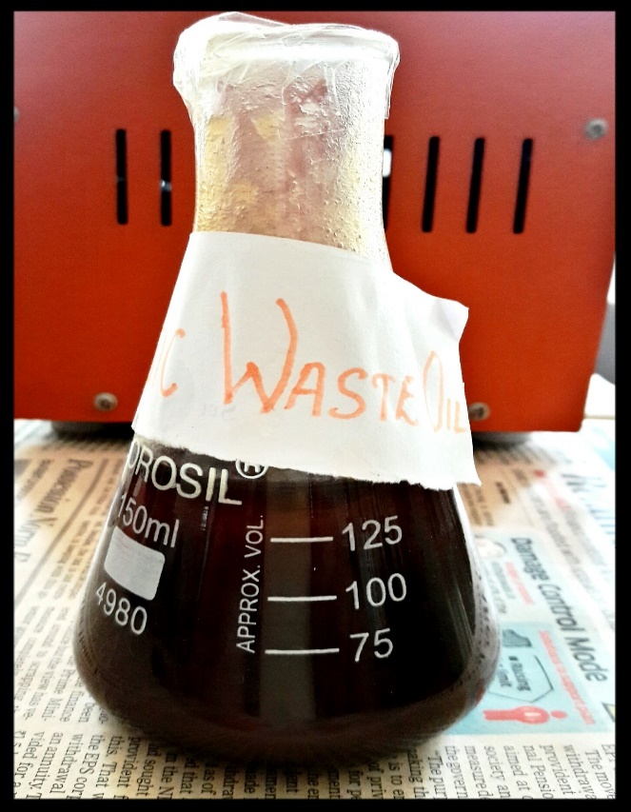

Figure 5.15: Final Raw fuel collected after separated it from water

**5.6 PHYSICAL PROPERTIES OF WASTE PLASTIC OIL**

|  |  |
| --- | --- |
| **Properties** | **Waste plastic oil** |
| Density at 300C (in g/cm3) | 0.874 |
| Kinematic Viscosity (Centistokes) | 4.31 |
| Flash point (in 0C) | 107 |
| Fire Point (in 0C) | 118 |

Table 5.1: Overall results for pyrolytic oil blends

**CHAPTER – 6**

**APPLICATION OF PROJECT & FUTURE WORK**

1. The obtained fuel could be utilized in diesel generators, vehicles such as tractors and also passenger vehicles such as cars.

2. The fuel has to be refined at the industrial establishments, based on the results of which small scale industry can be established.

3. As there is a high demand of crude oil and due to its sky reaching prices, we could take up this project to setup large or small scale industries and produce the fuel locally at much cheaper rates directly benefiting the National economy and also a step towards SWAACH BHARAT by recycling the waste plastic.

4. The application of this project could help in reducing the dependency on the gulf countries and promote a step towards innovation.

**CHAPTER - 7**

**RESULTS AND DISCUSSIONS**

1. Through our experimentation we concluded that about 300 to 450ml of diesel fuel could be obtained by burning 750gm of plastic. Burning 750gm of plastic in an open environment produces 3Kg of CO2, whereas by converting it into fuel and burning it reduces 80% of CO2 emissions, which results in to be quite environmentally friendly.

2. Lesser emission of unburnt HYDROCARBONS in waste plastic pyrolysis oil compared to that of diesel.

3. The diesel or oil thus obtained has a higher efficiency with around 30 to 40% low production cost compared to that available in the market.

**CHAPTER - 8**

**CONCLUSION**

It is very difficult to find out alternative of plastic. Even plastic’s demand is increasing every day as well as their waste. This project analysis has observed the use of waste plastics, a factory planning and its feasibility in Metropolitan City. It is easily assumed that, when the use of waste plastic will increase then the solid waste management will search more ways to find out to collect them.

The implementation of this project can develop So many opportunities in the city. It Can be a solution to control waste plastic, develop a new technique or idea, and detect the source of diesel for the country. Bangladesh is such a country where this kind of project could be very promising and effective in the future.

The use of plastic pyrolysis oil in diesel engine in the aspect of technical and economical is compared and found that oil is able to replace the diesel oil. Though the plastic pyrolysis oil offers lower engine performance, the plastic waste amount is enormous and it needed to be process to reduce the environmental problems. Moreover, the engine can be modify follow the combustion condition of plastic pyrolysis oil. The waste plastic used in the process must be PE or PP or LDPE in order to protect the contamination of chlorine in the oil.

**REFERENCES:**

[1] M. F. Ali, S. Ahmed, M. S. Qureshi, Catalytic coprocessing of coal and petroleum residues with waste plastics to produce transportation fuels Fuel Processing Technology 92 (2011) 1109–1120.

[2] Sumit Bhat and Rohit Singh Lather, “Production of Oil from Waste Plastics and Polythene using Pyrolysis and its Utilization in Compression Ignition (C.I.) Engine”, Vol 9(48), December 2016.

[3] Pawar Harshal R. and Lawankar Shailendra M, “Waste plastic Pyrolysis Oil Alternative Fuel for CI Engine”, Vol. 2(2), 26-30, February 2013.

[4] Senthilkumar Tamilkolundu and Chandrasekar Murugesan, “The Evaluation of blend of Waste Plastic Oil Diesel fuel for use as alternate fuel for transportation”, April 28-29, 2012.

[5] Sunbong Lee, Koji Yoshida & Kunio Yoshikawa, “Application of Waste Plastic Pyrolysis Oil in a Direct Injection Diesel Engine: For a Small Scale Non-Grid Electrification”, Vol. 5, No. 1; 2015.

[6] Mitusuhara, waste plastics to produce transportation fuels Fuel Processing Technology 72(2011).

[7] Anup T J, “Waste Plastic Pyrolysis Oil as Alternative for SI and CI Engines” International Journal of Innovative Research in Science, Engineering and Technology (An ISO 3297: 2007 Certified Organization) Vol. 3, Issue 7, July 2014.

[8] G. Elordi, M. Olazar, G. Lopez, “Catalytic pyrolysis of HDPE in continuous mode over zeolite catalysts in a conical spouted bed reactor,” Journal of Analytical and Applied Pyrolysis, vol. 85, no. 1-2, pp. 345–351, 2009.

[9] D. S. Scott, S. R. Czernik, J. Piskorz, and D. S. A. G. Radlein, “Fast pyrolysis of plastic wastes,” Energy & Fuels, vol. 4, no. 4, pp. 407–411, 1990.

[10] Mitusuhara, waste plastics to produce transportation fuels Fuel Processing Technology 72(2011)

[11] S. Hariharan, S. Murugan, G. Nagarajan, Effect of diethyl ether on Tyre pyrolysis oil fueled diesel engine. Fuel 104 (2013) 109–115, September 2012.

[12] A. K. Panda, R. K. Singh, and D. K. Mishra, “Thermolysis of waste plastics to liquid fuel. A suitable method for plastic waste management and manufacture of value added products—a world prospective,” Renewable and Sustainable Energy Reviews, vol. 14, no. 1, pp. 233–248, 2010.

[13] YB Sonawane1, MR Shindikar2, MY Khaladkar, “Onsite Conversion of Thermoplastic Waste into Fuel by Catalytic Pyrolysis.” International Journal of Innovative Research in Science, Engineering and Technology. Vol. 3, Issue 9, ISSN: 2319-8753

[14] J. Aguado, D. P. Serrano, and J. M. Escola, “Fuels from waste plastics by thermal and catalytic process: a review,” Industrial & Engineering Chemistry Research, vol. 47, no. 21, pp. 7982–7992,2008

[15] M. N. Siddiqui, H.H. Redhwi, Catalytic co-processing of waste plastics and petroleum residue into liquid fuel oils, Journal of Analytical and Applied Pyrolysis 86 (2009) 141–147